Workshop: Spain March, 2018

Assignments:
1.Locate the key words and
2. Write a summary about your country!

12 Stereotypes About The Spanish That Are DEFINITELY True

First, we debunked some of the stereotypes about the Spanish that are not true (you know: that we can all dance the flamenco; that we’re all fans of bullfighting; that we only eat paella). But now, it’s time to own up to the stereotypes that we have to admit ring true.
1. Our English is pretty bad.
Unfortunately, languages don’t come that easily to us, especially English. One of the reasons for this is that in Spain, films in most theaters are dubbed (as opposed to being in the original languages with subtitles), and that makes it difficult for us to develop a good ear and become familiar with the intonations of the language in question. We should also add that we’re terribly afraid of looking ridiculous, which doesn’t exactly push us towards trying out our new language skills.
2. We like to drink…
…and we’ll do it at any time, day or night. But that doesn’t mean we’re drunks — it’s just that alcohol (particularly wine) is a part of our culture. Also, let’s be real: We have the best wine in the world.
3. And we also love eating.
On the weekends, our lunches can last so long that they become dinner! Nobody leaves without a full stomach. That’s just a rule.
4. We’re very family-oriented.
Whether it comes to enjoying a feast, going out to a party or even, if it just so happens, attending the Oscars— family comes first. A shout out to our sister (Penélope Cruz), our mother (Javier Bardem) or any other close family member is a must.
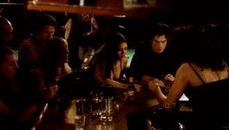
5. We have SO MANY bars.
We usually say that there’s a bar for every local, and that’s not as exaggerated as it seems. A study done by Coca-Cola in 2013 showed that there is one bar for every 132 inhabitants. In other words, there are a total of 350,000 bars for the 47.2 million inhabitants of the country. Pick your poison!
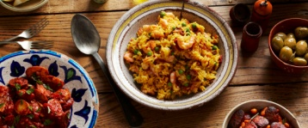
6. We cook well (very well).
In Spain we have a grand, rich and varied cuisine. Gazpacho, pisto, cocido, empanadas, octopus, migas… and, of course, the Spanish potato tortilla. Furthermore, we have 171 Michelin starred restaurants, of which 8 have the highest rating possible (three stars).
7. We’re very affectionate, even with new acquaintances.
We like to give hugs. We kiss upon meeting new people, AND when we say goodbye. Also, we always kiss each other from right to left, exactly the opposite of the French, of course.
8. We speak very loudly.
Sometimes we could be said to be screaming when talking.
9. We are on a different schedule from much of the rest of Europe.
We start the day very late, we eat lunch late, we eat dinner incredibly late, and we go to bed even later. When the rest of Europe has already been asleep for two hours, in Spain we’re still watching films or a soccer match (games scheduled on Mondays at 10:00pm are not unusual).
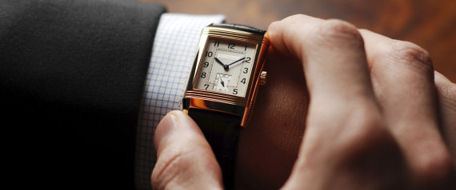
10. We’re always late.
For some reason, we don’t know why, we can’t help but be tardy all the time. It must be in our genes.
11. We love free stuff.
Everyone loves freebies, but we really love them. It doesn’t particularly matter whether we even want or need the free item; we’ll still wait in line for it cause it’s FREE.

12. Soccer is EVERYTHING to us.
Just look at these photos from Madrid during the final game of the Champions League between Real Madrid and Atlético (also from Madrid) in Lisbon. The capital was totally deserted. Sort of how it was when we won the World Cup in South Africa. And a survey done by the IG-Investiga Institute determined that more than half of the country declares themselves avid fans of soccer (or, “the king sport”).
This post is a translated and adapted version of El Huffington Post’s original.
https://www.huffingtonpost.com/2014/09/24/spanish-stereotypes-true-_n_5837296.html

